COAL LAB 1

- DOSBox link
https://www.dosbox.com/download.php?main=1
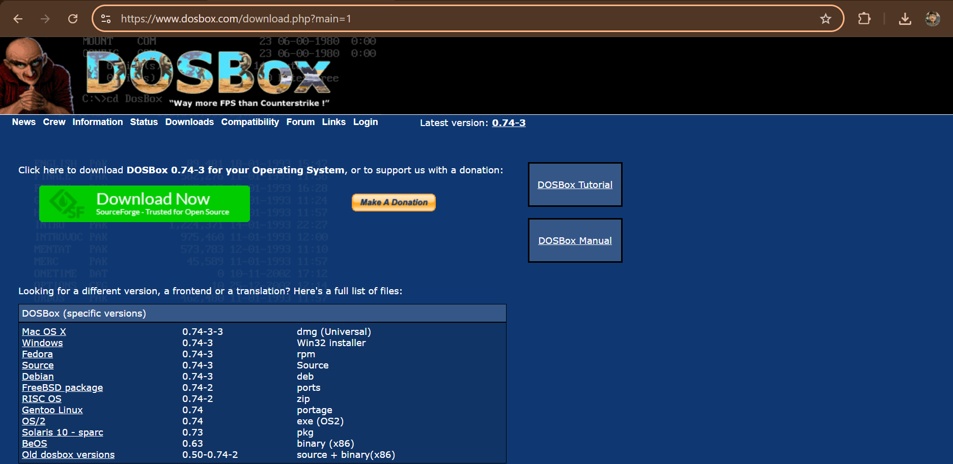

- Opening
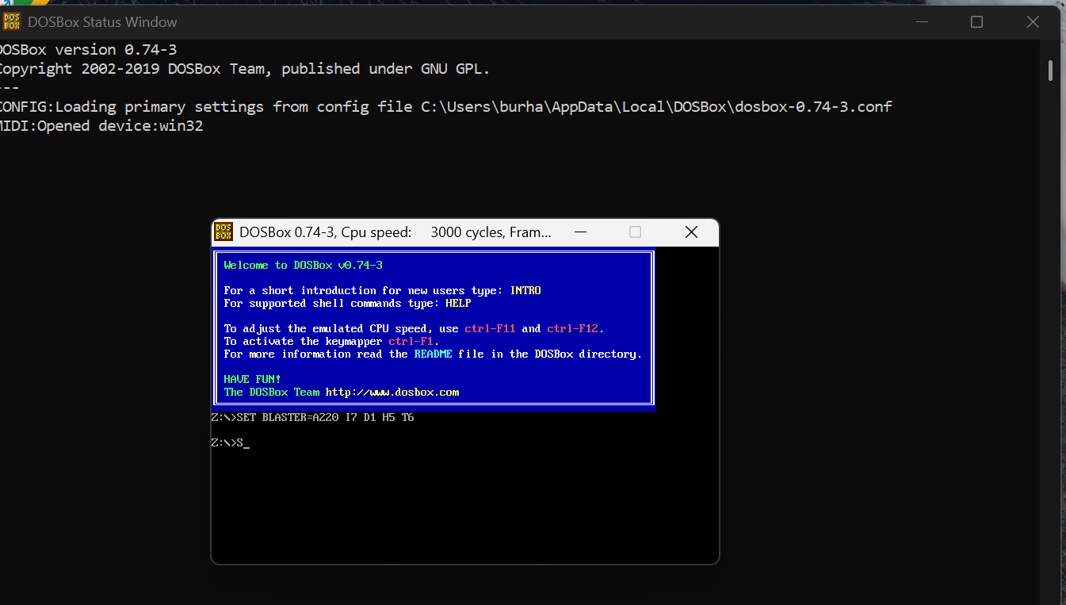

- Mount Drive
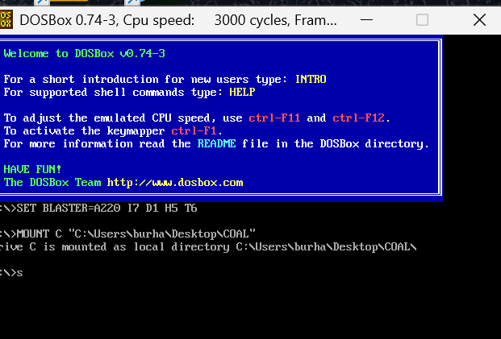
- UNMOUNT
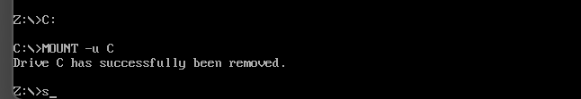
- DIR
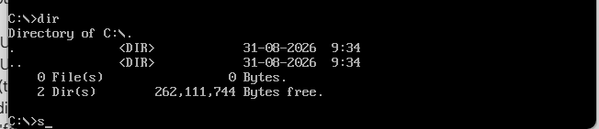

- New folder
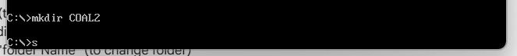
- Open new folder
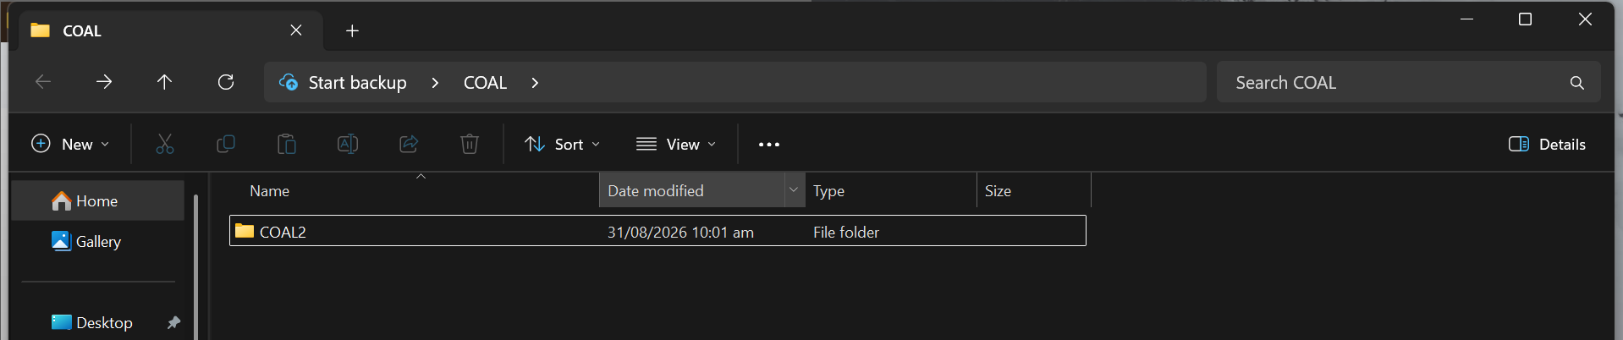

- Change root
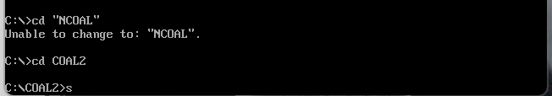
- previous


